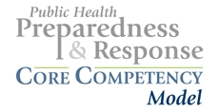

Performance Goal: Proficiently perform assigned prevention, preparedness, response, and recovery role(s) in accordance with established national, state, and local health security and public health policies, laws, and systems.
Much of an individual worker’s ability to meet this performance goal is grounded in competencies acquired from three sources, as applicable to the worker’s level of training and position/role:
- Foundational public health competencies, such as the Council on Linkages Between Academia and Public Health Practice Core Competencies for Public Health Professionals and the ASPH Master’s Degree in Public Health Core Competency Model for those in the target group with specific training in public health;
- Generic health security or emergency core competencies, such as those which may stem from NIMS courses or competency sets pending from various national initiatives; and,
- Position-specific or professional competencies, such as those developed for public health nursing, environmental health, public health law, applied epidemiology, administrative support, and informatics.
Beyond these sets, competencies in the following four domains are critical to build and sustain the capacity of public health workers to fulfill their responsibilities:

1. Model Leadership
1.1 Solve problems under emergency conditions.
1.2 Manage behaviors associated with emotional responses in self and others.
1.3 Facilitate collaboration with internal and external emergency response partners.
1.4 Maintain situational awareness.
1.5 Demonstrate respect for all persons and cultures.
1.6 Act within the scope of one's legal authority.

2. Communicate and Manage Information
2.1 Manage information related to an emergency.
2.2 Use principles of crisis and risk communication.
2.3 Report information potentially relevant to the identification and control of an emergency through the chain of command.
2.4 Collect data according to protocol.
2.5 Manage the recording and/or transcription of data according to protocol.

3. Plan for and Improve Practice
3.1 Contribute expertise to a community hazard vulnerability analysis (HVA).
3.2 Contribute expertise to the development of emergency plans.
3.3 Participate in improving the organization’s capacities (including, but not limited to programs, plans, policies, laws, and workforce training).
3.4 Refer matters outside of one's scope of legal authority through the chain of command.

4. Protect Worker Health and Safety
4.1 Maintain personal/family emergency preparedness plans.
4.2 Employ protective behaviors according to changing conditions, personal limitations, and threats.
4.3 Report unresolved threats to physical and mental health through the chain of command.

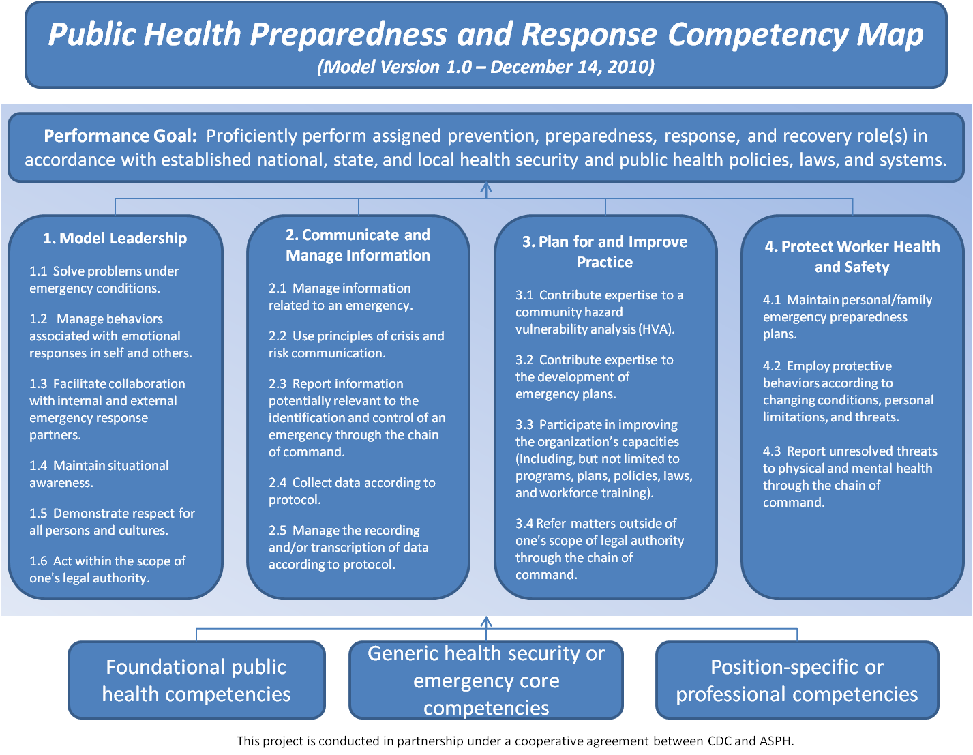

Tenets, Target Audience, and Performance Level
for the Public Health Preparedness and Response Core Competency Model Version 1.0
(December 17, 2010)

Supported by the Centers for Disease Control and Prevention (CDC) Office of Public Health Preparedness and Response, the Association of Schools of Public Health (ASPH) has built upon existing work to provide a national framework for competency-based curricula and training and for performance benchmarks to measure public health preparedness and response. The finished model — the Public Health Preparedness and Response Core Competency Model Version 1.0 — fulfills a mandate in the 2006 Pandemic and All-Hazards Preparedness Act to develop “a competency-based training program to train public health practitioners.” It represents individual, core competencies that mid-level public health workers, regardless of their employment setting, are expected to demonstrate to assure readiness.

ASPH and the CDC used a transparent, participatory process from April 2009 to December 2010 to develop, vet, and finalize this model. Over 400 individuals from federal, tribal, state, and local public health practice and from academe contributed to the process as volunteers in three rounds of electronic stakeholder input and in expert workgroups. A 16-member Leadership Group worked with ASPH staff, CDC officials, and consultants to guide the project.

Tenets
The Leadership Group established the following project tenets, stating that the resulting competency model would:
- Align with established capabilities
- Utilize an all-hazards approach, spanning across the prevent, protect, respond, and recover missions
- Provide a proposed national standard for mid-level public health workers across all sectors and settings
- Be behaviorally-based, focusing on observable actions
- Reflect and build upon existing competency models
- Supplement existing core public health competency models
- Inform curricular planning for the workforce
- Be utilized by the CDC Preparedness and Emergency Response Learning Centers (PERLC)* grantees in 2010
- Be available to other public and private entities.
* PERLC are the new iteration of the Centers for Public Health Preparedness.

Target Audience
The model defines a mid-level public health worker as an individual with:
- Five years experience with an MPH equivalent or higher degree in public health, or
- 10 years experience with a high school diploma, bachelors, or non-public health graduate degree.

Aside from years of experience and education, these workers may have responsibilities for: program support, coordination, development, implementation, management and/or evaluation; supervision; establishing and maintaining community relations, presenting arguments and recommendations on policy issues, etc.

To provide a few examples, mid-level public health workers could include:
- Administrative supervisors, such as payroll supervisors, purchasing managers, and human resources staff;
- Chief clerks of vital records;
- Public health nurses who run well-child clinics, immunization programs, STD testing, and/or who also may assist with epidemiological tasks; and,
- Public health sanitarians who: undertake routine food, water, pool, and/or restaurant inspections; conduct food worker training; and/or may help with epidemiological tasks

Such mid-level workers may or may not directly provide the 10 essential public health services as part of their daily jobs. In the event of an “all hands on deck” emergency, however, organizational leaders may need to use the full range of available human resources to support response and recovery. Each organization will make a decision about which employees to include in the audience for training and exercises applying these core competencies.

Performance Level
The model targets proficiency as the level of competence required to assure readiness. Workers may begin as novices and some may be required by a specific position or activity to achieve expert competence.

